Translation Vektorgraphiken sw

Phase 1

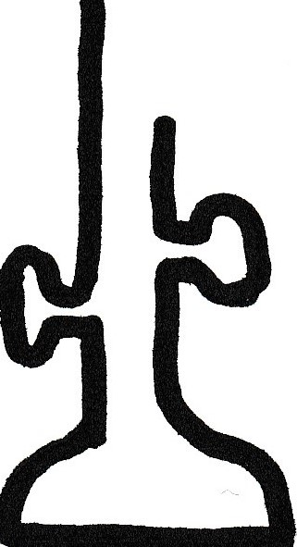
G C A
Arg
Met
Ser
Ser
A U G A G U U C G G C U A A A C G U C C C U U A G C G
C G A
Ala
Lys

3‘
U U U

5‘

E P A

Phase 2

Met
Ser
Ser
A U G A G U U C G G C U A A A C G U C C C U U A G C G
Ala
Lys

3‘

U U U

G C A
Arg

5‘

Phase 3

Met
Ser
Ser
A U G A G U U C G G C U A A A C G U C C C U U A G C G
Ala
Lys

3‘
U U U

Arg

G C A

5‘

Phase 4

Met
Ser
Ser
Ala
Lys

3‘

U U U

Arg

G C A

5‘
A U G A G U U C G G C U A A A C G U C C C U U A G C G

Phase 5

Met
Ser
Ser
Ala
Lys

3‘

Arg

U U U

G C A

5‘
A U G A G U U C G G C U A A A C G U C C C U U A G C G

